Recap of the Relational Database Systems

Class Exercise 1:
Test your proficiency in designing, implementing, and using a database by recalling the skills gained during the previous course.
The following are the steps involved in designing and implementing a database, given some requirements.
- Requirements Analysis
- Conceptual Model
- Normalization
- ERD
- Database Schema
Objective: Create a database based on a brief set of requirements provided.
“In a University, there are various schools (eg. SBE, SAFS etc.). Each school has one or more departments (eg. CS, IT, Nursing etc). Each department has its programs (eg. BCT, BIT, BCS, BEd. Etc). When a student is admitted into the University, he/she is enrolled into a program.”
Use the above information to;
- Requirements analysis - Summarize the above case into (entities, relationships, cardinalities, and attributes)
- Translate the above requirements into a conceptual model
- Normalize the conceptual model in b (above)
- Translate the conceptual model into an ERD
- Translate the ERD to a physical model (Create a database)
While making reference to the database schema generated after completing the above exercise, test your basic SQL proficiency by attempting to write SQL query commands to;
- List the names and email of all students

- List the names and email of all students whose names begin with ‘MA’
- List the names and email of all students registered for ‘BIT’
- List the names and email of all students from ‘Nursing’ department
- List the names and email of all students taking programs from Nursing and IT departments.
- List the names of programs with no students enrolled.

Class Exercise 2: Library database.
The purpose of the database is to facilitate staff members to issue books to the library patrons. The three major entities (table) are:
- Staff – staff members of the library
- patrons – registered users of the library.
- Books – Library inventory or items
How are these entities related? In this problem we need to know which books are issued to which patrons and by whom (staff). Thus, the relationship “issues/issued” becomes an obvious and an important relationship in this simple problem. Normalizing the design, the relationship is represented using a new entity, “issues”. Finally, the resulting Entity-Relationship Diagram is as follows;
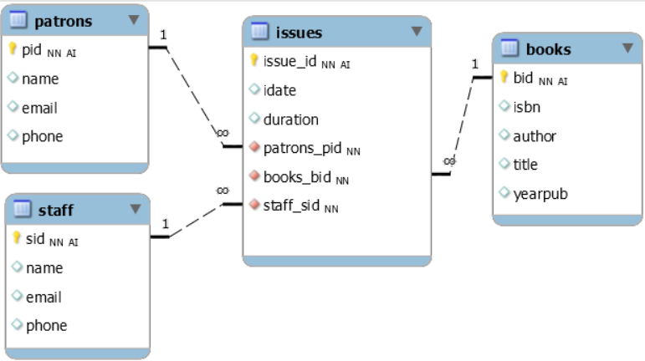
While making reference to the ERD above, test your basic SQL proficiency by attempting to write commands to;
- List the names and email of all patrons whose names contain “th”.
- List the names and email of all patrons who have ever been issued with a book authored by ‘Stephen Mutua’
- List the name and email of patrons issued with books on 2021-10-07.
- List the name of patrons, name of staff, and the title of all books issued on 2021-10-07.
- List the names and email of staff who did not issue any book on 2021-10-07
Class Exercise 3: Rewriting Queries
1. Write a query to retrieve the name and phone of students taking a level 2 program in the school named 'SEA'
- Use cartesian product
- use joins
2. Rewrite the following query to use a JOIN instead.

